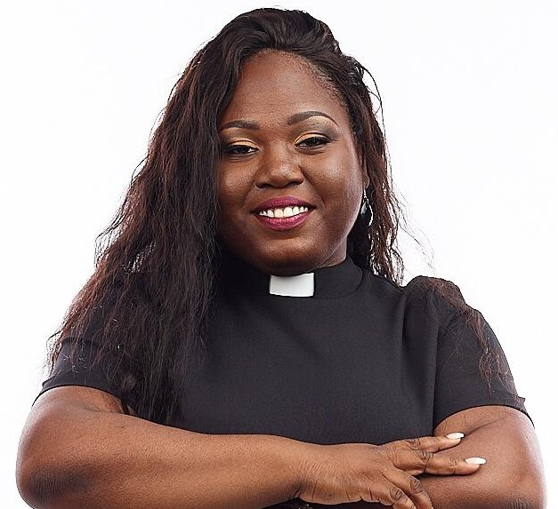

**Dear Valued Customer,**

Firstly, let me say thanks for your interest in booking me for your upcoming event. Kindly see basic requirements below to ensure a smooth and seamless performance. Please note that there may be changes based on circumstances and/or your unique or special requests.

* **Hospitality Rider**
* About 15 minutes to one (1) hour to get settled and or set up; therefore, we may need access to and or accommodation at the location. This should include access to dressing room (where necessary), rest room and contact person.
* Two (2)bottled water at room temperature: Catherine’s Peak, Lifespan or any other spring water, preferably.
* Paper towel or rag
* **Technical Rider**
* At least 15 minutes to an hour set-up time
* Two chair
* For Solo performances, tracks will be provided in advance for your Sound Engineer through the email address of the event organizer

***Contact:*** [management.pr@outloook.com](mailto:management.pr@outloook.com) 917-997-6940 (WhatsApp) |876-546-1257 | 315-221-8458